**Why Is EUV Important – Bryan Carty (19235836)**

Thirty years of innovation in physics, chemistry and material science have lead us to the periphery of a future where Extreme ultraviolet Lithography is feasible. The continued production of IOT devices, as well as the exponential growth of AI and autonomous driving technologies mean we must constantly strive for chips that are smaller, lighter, cheaper and have lower power consumption. The integrated circuit of the 20th century was arguably the spur that incited a technological revolution. Thus, it’s justifiable to question where the next generation of integrated circuits will steer us and why they’re important to the evolution of technology, other industries and the global economy.

**Direct Reasons – Bryan Carty (19235836)**

For the semiconductor industry EUV is Moores laws saviour, preventing it from having to spend billions on research in other means of creating smaller and more efficient integrated circuits. Additionally, since 1965 Moores law has been a motivating force that has stimulated the cutting edge innovation that we’ve experienced in the past 55 years.

Arguably, the biggest impact of EUV will be on the semiconductor industry. [1] Samsung was the first to claim it will produce chips for customers using EUV tools and in [2]2018 they announced that they finalised their process for EUV and that the international version of the Galaxy Note 10 launched with the Exynos 9825 processor which is Samsung’s first product partially made with EUV. But GlobalFoundries , Taiwan semiconductor manufacturing Company and Intel were not far behind. [3]According to a report done by MarketsAndMarkets “The EUV lithography market (EUVL) is expected to increase from USD 1.24 billion in 2017 to USD 10.31 billion by 2023”. Extreme Ultraviolet Lithography’s reason for being so prominent in the semiconductor industry today is because it uses 13.5-nm light. With it, manufacturers can substantially reduce the number of lithography steps. [4]For example GlobalFoundries will replace 15 steps with just 5 for its 7-nm EUV process. This makes the work at 7nm considerably faster and cheaper. [5]Extreme Ultraviolet Lithography enables the use of only one mask exposure instead of multiexposure.

[6]Extreme Ultraviolet Lithography is important as it has more advantages over other optical lithographies. For one it is said to achieve more depth of focus and linearity for dense and isolated lines when compared to its counterparts. Additionally, the superior critical dimension control and image placement have been obtained as a result of the low thermal expansion substrates. It has also been shown that the existing DUV resists can be extended for use with Extreme Ultraviolet Lithography.

**Indirect Reasons – Bryan Carty (19235836)**

The technology industry has a major impact on many sectors. Therefore it’s certain that Extreme Ultraviolet lithography will play an influential role in the innovation of other sectors. The health care industry is one sector that will benefit from improvements in technology and therefore extreme ultraviolet lithography. According to Technavio, “The global digital healthcare market is poised to grow by USD 207.34 billion during 2020-2024”.

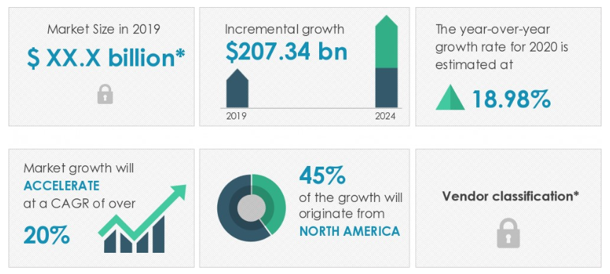

(Source: technavio.com – report - Digital Health Market by Application and Geography - Forecast and Analysis 2020-2024 )

Other areas that are likely to benefit from more advanced integrated circuits and therefore Extreme Ultraviolet Lithography are sectors partaking in research that handles a large amount of data. [7]For example the next generation of particle accelerators are expected to generate trillions of events every second. Currently we don’t have adequate equipment to make sense of that amount of data. We therefore need faster computers with larger data storage. Neither of which are possible without more advanced integrated circuits.

The global agriculture tech market is another sector primed for growth in the coming years. According to a BIS Research market intelligence report [8]the agriculture technology market is expected to generate 2.49 billion USD in revenue by 2024. The introduction of smart technologies into the farming workplace has been driven by the need for increased global food production. This demand for greater food production is expected to continually rise and thus a greater demand for more effective and efficient farming technology is likely to ensue. Similar to how a greater demand for medical technology will require more efficient integrated circuits, the farming sector will also require similar criteria. Therefore Extreme Ultraviolet Lithography is vital to the advancement of our sectors as well as the expansion of our economy.

As well as there being faster, cheaper and more efficient technology in the coming years there is expected to be an overall increase in the number of technological devices ergo an increase in the quantity of data generated by devices. Yet again, there is a need for a better generation of integrated circuits to handle these larger quantities of data. These more advanced circuits will most definitely require Extreme Ultraviolet Lithography to be manufactured.



(Source: BI Intelligence Estimated Amount Of Data Generated By The Average Farm Per Day)

According to Energias Market Research “The Global Extreme Ultraviolet Lithography (EUVL) Market is expected to grow from USD 759.8 Million in 2017 to USD 1,453.06 Million in 2024 at a CAGR of 9.7% during the forecast period from 2018 to 2024”. [9]The driving force behind this growth is expected to be the increasing demand for compact integrated circuits. More specifically, industries such as electronics and automotive are likely to claim great benefit from more compact and faster integrated circuits. This brings about another reason why Extreme Ultraviolet Lithography is important. Extreme Ultraviolet Lithography will create numerous jobs as a result of the industry growth in the coming years. This will also have beneficial implications for the global economy.

**References**

[1]` EUV Lithography Finally Ready for Chip Manufacturing by Samuel K. Moore

[2] EUV: Lasers, plasma, and the sci-fi tech that will make chips faster by Engadget

[3] EUV Lithography Market (EUVL) by End User (Integrated Device Manufacturer (IDM) and Foundry Companies), Equipment (Qualitative), and Geography (The Americas and Asia Pacific) - Global Trend and Forecast to 2023 by MarketsAndMarkets

[4] EUV Lithography Finally Ready for Chip Manufacturing by Samuel K. Moore

[5] CMOS Past, Present and Future, 1st Edition. Authors: Henry Radamson Eddy Simoen Jun Luo Chao Zhao

[6] EUV lithography update, from oemagazine June 2002, by Charles Gwyn

[7] The Extreme Physics Pushing Moore’s Law to the Next Level by Seeker

[8] Global Agriculture Technology-as-a-Service Market: Focus on Service Type (Software-as-a-Service, Equipment-as-a-Service), Technology (Data Analytics, Guidance, Sensing, Variable Rate), Application (Yield Mapping, Soil Management, Crop Health), Pricing Models, Break-Even Analysis – Analysis and Forecast, 2019-2024 by BIS Research

[9] Energias Market Research - Global Extreme Ultraviolet Lithography (EUVL) Market to Witness a CAGR of 9.7% During 2018 to 2024: Energias Market Research